logo

Department of Electronics and Communication Engineering

THE LNM INSTITUTE OF INFORMATION TECHNOLOGY, JAIPUR

*(DEEMED TO BE UNIVERSITY)*

Gram Rupa-Ki-Nangal, Post-Sumel, Via Jamdoli, Jaipur-302031, Rajasthan, India

**ECE103: ELECTRONICS I**

**First Mid-Term Examination, 21st August 2014**

**Duration: 60 minutes Max. Marks: 15**

NOTE: Attempt all questions. All questions carry equal marks. Do not answer the same question more than once. Start the answer to a new question on a new page.

While solving the problems, make suitable assumptions wherever necessary, and state those assumptions clearly.

1. In the electrical network shown in Figure 1, calculate the values of the currents Ix and Iy. Use any method of analysis that you feel comfortable with.

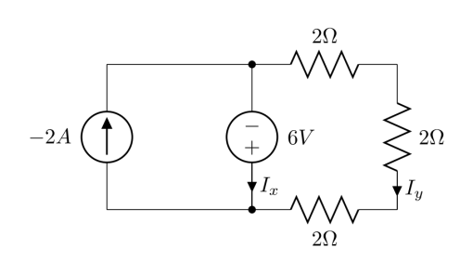

Figure 1

1. The output voltage waveform of an electrical network called half-wave rectifier is shown in Figure 2. If VMAX=10 volts, compute the average value of the signal over a full cycle (abbreviated as VDC (EQ) in Figure 2). Also calculate the root-mean-square value (abbreviated as VRMS in Figure 2). Note that the voltage is of sinusoidal nature in the first half of the cycle, and zero in the second half of the cycle.

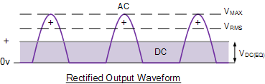Figure 2

1. Calculate the value of the resistance of a light-bulb (assuming that it is acting as a pure resistor) that consumes an average power of 75.0W when connected to a 60Hz sinusoidal voltage source with a peak voltage value of 170V.

1. A 50.0 ohm resistor, a 0.100 Henry inductor, and a 10.0 micro-Farad capacitor are connected in series to a 60.0Hz sinusoidal voltage source. The RMS value of the current in the circuit is measured to be 2.75 Amperes. Compute the RMS value of the voltage that would be measured across a) the resistor, b) the inductor, and c) the capacitor.

1. Repeat question 4 for a 159Hz sinusoidal voltage source.

**SOLUTIONS**

* 1. KCL yields the following equation:

-2-Ix +{(0-(-6))/6}=0 which yields Ix=-1 Ampere. The current Iy is easily calculated to be -6/6 = -1 Ampere.

EVALUATION STRATEGY: 1.5 marks for ability to write correct equations, and 1.5 marks for correct calculations.

* 1. The answers are given below:

Average Value = Vmax/≈0.318Vmax=3.18 volts

RMS value = Vmax/=0.500Vmax=5.00 volts

EVALUATION STRATEGY: 1.5 marks for ability to write correct equations, and 1.5 marks for correct calculations.

* 1. We write the following equation: 75=Vpeak2/(2R) which gives R=(170*170)/150≈192.67 Ω.

EVALUATION STRATEGY: 1.5 marks for ability to write correct equations, and 1.5 marks for correct calculations.

* 1. R=50.00 ohm, XL≈37.7 Ω, XC≈265.26 Ω. Therefore, the impedance of the entire circuit is Z≈50-j227.56 Ω which can also be written approximately as Z≈233 ∟ -77.610Ω. The RMS value of the voltage across the resistor=50.00*2.75=137.5 volts. The RMS value of the voltage across the inductor≈37.7*2.75≈103.68 volts. The RMS value of the voltage across the capacitor≈265.26*2.75≈729.47 volts.

EVALUATION STRATEGY: 1.5 marks for ability to correctly formulate the problem, and 1.5 marks for correct calculations.

* 1. R=50.00 ohm, XL≈99.9 Ω, XC≈100.1 Ω. Therefore, the impedance of the entire circuit is Z≈50 Ω. The RMS value of the voltage across the resistor=50.00*2.75=137.5 volts. The RMS value of the voltage across the inductor≈100*2.75≈275 volts. The RMS value of the voltage across the capacitor≈100*2.75≈275 volts.

EVALUATION STRATEGY: 1.5 marks for ability to correctly formulate the problem, and 1.5 marks for correct calculations.